Assignment – 3

• Use the Employee Details dataset and perform the following activities: -

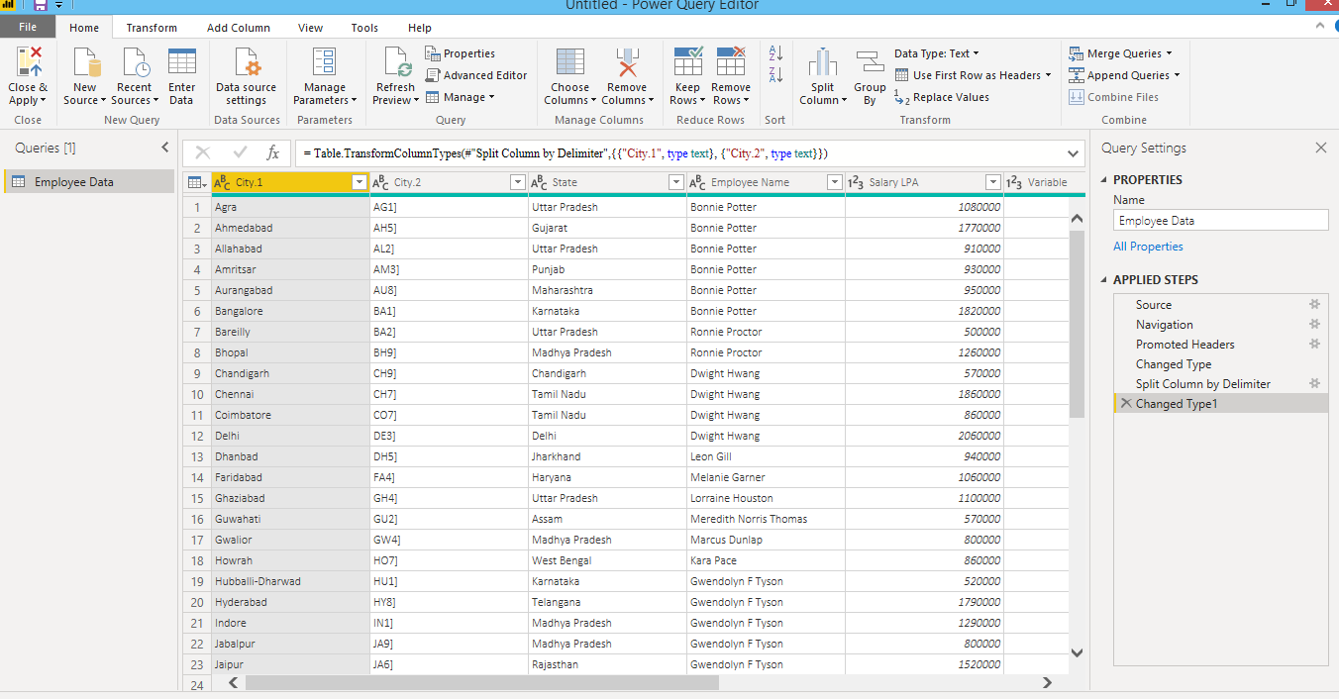− Split the column CITY and separate the code associate with each city like - Allahabad[AL2] should be only Allahabad and [A2] will be separate.

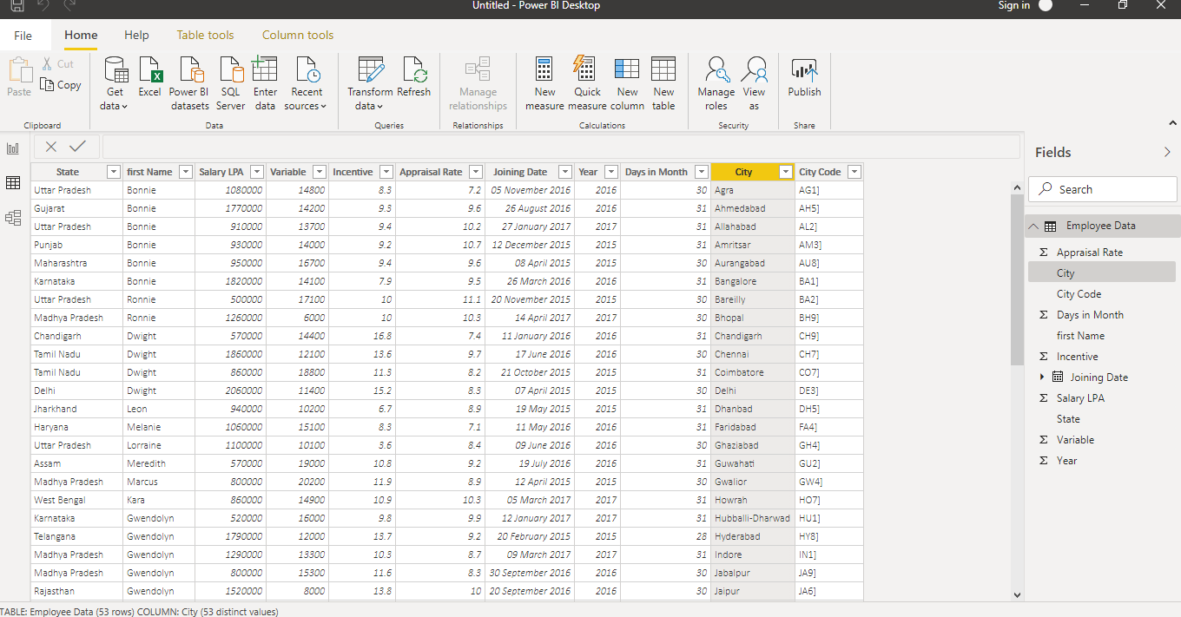

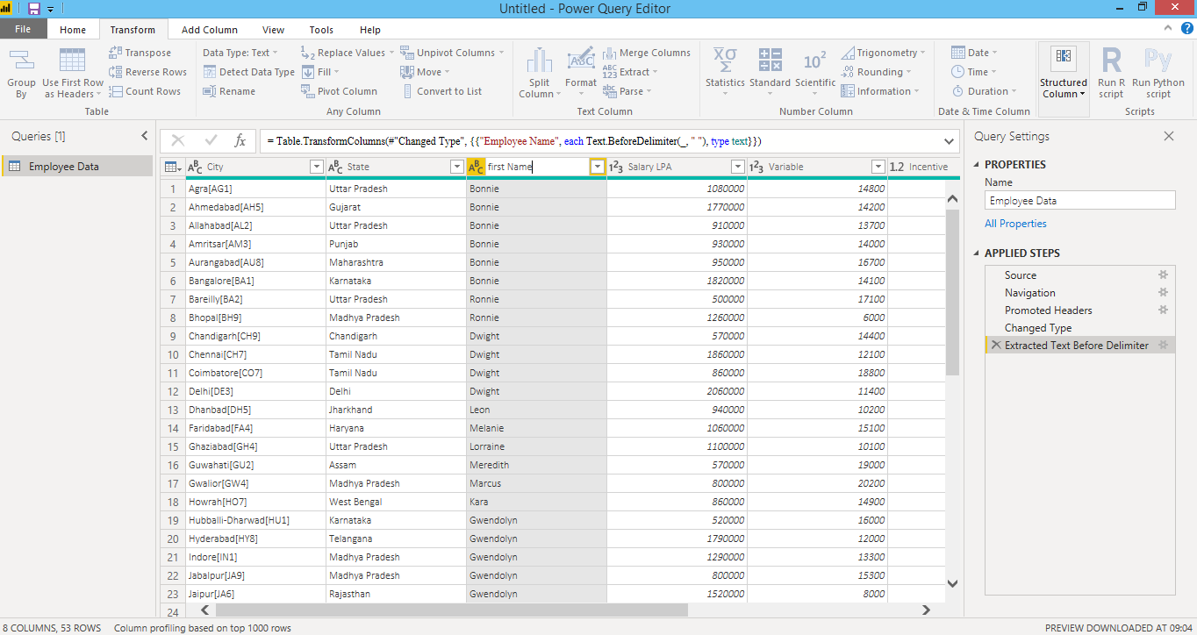**Extract the first name from EMPLOYEE NAME column and transform the column.**

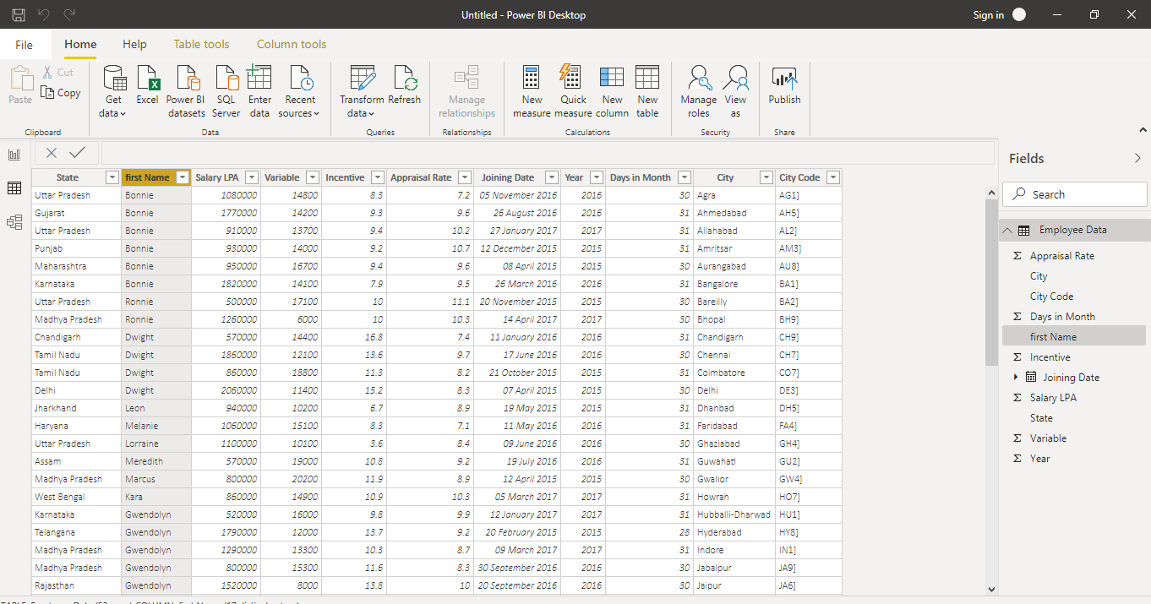

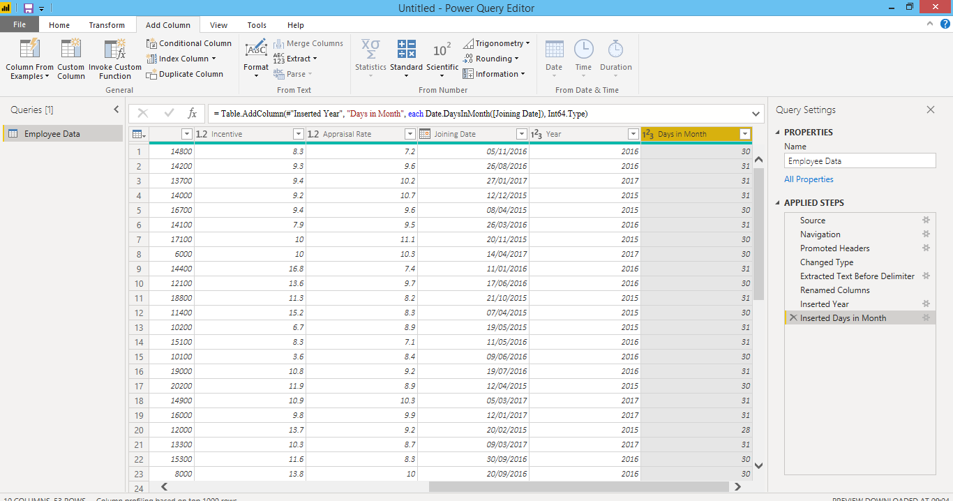**Using the JOINING DATE column extract the Year and no. of days for that month**

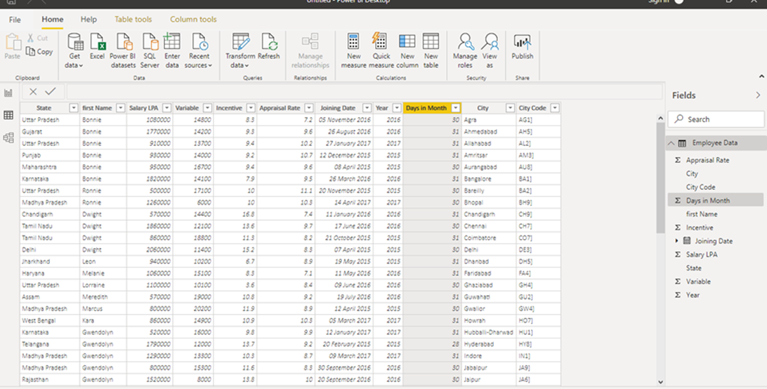

**Create a visual of your choice and show the how much salary has been paid to each state and which state has lowest pay-out.**

